SVU COLLEGE OF ENGINEERING::TIRUPATI

**DEPARTMENT OF COMMERCE**

|  |  |  |  |
| --- | --- | --- | --- |
| **Faculty Profile** | |  | | --- | |  |   **E:\desktop\New folder (3)\New folder (2)\New folder\1000.jpg** | |
| **Name of the faculty** | **:Dr Morusu Sivasankar** | |
| **Date of Birth** | **:02/03/1976** | |
| **Designation** | **:Academic consultant** | |
| **Department** | **: Commerce** | |
| **Qualification** | **: M.Com., Ph.D., PDF (UGC)**  **M.Sc., (IT) MBA M Tech (CS)**  **MA (Economics)** | |
| **Memberships** | **:** Life member of Indian Science Congress Association **Number L31169** | |
| **Experience** | **Teaching: Research:** | |
| **Publications** | **Journals** | **Conferences** |
| **92** | **42** |
| **Workshops/Training Programmers** | **Organized** | **Participated** |
|  | **4** |
| **Research Areas** | **: Industrial Finance** | |
| **Present Positions** | **: :Academic consultant** | |
| **Positions Held** | **: SVUCE** | |
|  | **:** 99853 12506 | |
| **Any Other details**  **(Research projects/academic activities etc)** | **:** | |

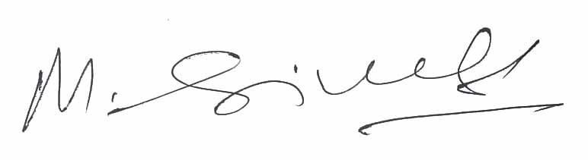

Signature of faculty